Visvesvaraya Technological University

BelAgaVI-590 018


Internship / Professional Practice Report
on

“Finding the stage of cancer as malignant or benign using Logistic Regression”

Submitted in partial fulfillment of the requirements for the Final year degree of Bachelor of Engineering in Computer Science and Engineering
of Visvesvaraya Technological University, Belagavi

by

Varsha Ravindra 1RN15CS119

Carried out at
TechieAid

Under the Guidance of:

Internal Guide: External Guide:
Dr. Shashidhara H R Mr. Jagadeesh
Assistant Professor Software Engineer and Mentor
Dept. of CSE TechieAid


Department of Computer Science and Engineering
R N S Institute of Technology
Channasandra, Dr.Vishnuvardan Road, Bengaluru-560 098
2018-2019

R N S Institute of Technology
Channasandra, Dr.Vishnuvardan Road, Bengaluru-560 098

Department of Computer Science & Engineering

Internship CERTIFICATE

Certified that the Internship/ Professional Practice work entitled “Finding the stage of cancer as malignant or benign using Logistic Regression” has been successfully carried out at “TechieAid”, by Varsha Ravindra bearing 1RN15CS119, bonafide student of RNS Institute of Technology in partial fulfilment of the requirements for the Final year degree in Bachelor of Engineering in Computer Science and Engineering of Visvesvaraya Technological University, Belagavi during academic year 2018-2019. It is certified that all corrections/suggestions indicated for Internal Assessment have been incorporated in the report deposited in the departmental library. The Internship report has been approved as it satisfies the academic requirements in respect of Internship work for the said degree.

Dr. Shashidhara H R Dr. G T Raju Dr. M K Venkatesha
Assistant Professor Vice -Principal Principal
Professor, HoD-CSE

External Viva:
Name of the Examiners Signature with Date
1.
2.

ACKNOWLEDGMENT
ABSTRACT

The project proposes the system to create a model that predicts the stage of breast cancer in the patient using logistic regression by taking the data from Breast Cancer Wisconsin dataset. The system is going to work on the data set which consist of attribute such as radius mean, texture mean, perimeter mean, smoothness, compactness etc. In order to work on these dataset find the correlation between each column and select the most important column in order to train out the model.
The aim is to create a model which gives a good prediction on the type of cancer a patient has whether is malignant or benign, as it is important to be sure about the type of cancer in order to start the treatment of patient. The use of logistic regression on this dataset helps one to check if it gives a good accuracy or not. In order to achieve this task one can divide the data set into two part which are Training set and Testing set, then can train the model using the training set and test using the testing dataset.
The accuracy of the model is improved by finding the best correlation between each attribute of data set and by adjusting the split ratio of training and testing dataset. One can develop the breast cancer detection model based on the machine learning algorithm for this purpose. Further to show high level of accuracy one use the Random Forest module, which extracts the high percentage of accurate result from the given model.

i
ACKNOWLEDGMENT
At the very onset, I would like to place on record our gratefulness to all those people who have helped us in making this internship work a reality. Coming up with this Internship work to be a success was not easy. Our Institution has played a paramount role in guiding us in the right direction.
I would like to profoundly thank the Management of RNS Institute of Technology for providing such a healthy environment for the successful completion of this Internship / Professional Practice work.
I would like to express my sincere thanks to our respected Director, Dr. H N Shivashankar for his constant encouragement that motivated me for the successful completion of this work.

I would also like to thank our beloved Principal, Dr. M K Venkatesha, for providing the necessary facilities to carry out this work.

I am extremely grateful to our beloved Vice–Principal and HoD-CSE, Dr. G T Raju, for having accepted to patronize me in the right direction with all his wisdom.

I place my heartfelt thanks to all the Coordinators- Internship / Professional Practice. I would like to thank the internal guide Dr. Shashidhara H R, Assistant. Professor, for his continuous guidance and constructive suggestions for this work.

It’s my pleasure to thank TechieAid for providing me the best platform to complete the internship work and glad to thank the extremal guide Mr. Jagadeesh, Software Engineer, for corporate exposure, training and guidance.

Last but not the least, I am thankful to all the staff members of Computer Science and Engineering Department for their encouragement and support throughout this work.

Varsha Ravindra
1RN15CS119

ii
TABLE OF CONTENTS
Sl. No. Chapter Name Page No.
 | ABSTRACT | i
 | ACKNOWLEDGEMENT | ii
 | TABLE OF CONTENTS | iii
 | LIST OF FIGURES | iv
 | LIST OF TABLES | v

- INTRODUCTION 01
  - ORGANIZATION/ INDUSTRY
    - Company Profile
    - Domain/ Technology (Data Science/Mobile computing/…)
    - Department/ Division / Group
  - PROBLEM STATEMENT
    - Existing System and their Limitations
    - Proposed Solution
    - Problem formulation
- REQUIREMENT ANALYSIS, TOOLS AND TECHNOLOGIES 05
  - Hardware & software requirements
  - Functional requirements
  - Tools, language and platform used
- DESIGN AND IMPLEMENTATION 11
  - Block diagram
  - Functional modules
  - Algorithm and Pseudo code
  - Overview of the libraries used
  - Configuration
- OBSERVATIONS AND RESULTS 22
  - Testing
  - Graphs
  - Results/ Snapshots
- CONCLUSION AND FUTURE WORK 30
6.1. Conclusion
6.2. Limitations and Future work
- REFERENCES 31

iii

LIST OF FIGURES

Figure No. Figure Name Page no.

Figure 2.1 | Kernel Execution | 06
Figure 2.2 | User to Notebook Interface | 06
Figure 3.1 | Block diagram | 11
Figure 3.2 | Dependency between two Dataset | 14
Figure 3.3 | Supervised Learning Workflow | 15
Figure 4.1 | Dataset Loaded | 22
Figure 4.2 | Splitting the dataset into the ratio 4:1 | 23
Figure 4.3 | Accuracy using Logistic Regression | 24
Figure 4.4 | Accuracy using Random Forest Algorithm | 25
Figure 4.5 | Diagnosis Count | 26
Figure 4.6 | Relation between average area and perimeter of the Tumor | 26
Figure 4.7 | Correlation Square showing relation between each columns | 27
Figure 4.8 | Importing required libraries and reading the dataset | 28
Figure 4.9 | Choosing X and Y for Training the model | 28
Figure 4.10 | Splitting data into training and testing set in ratio 4:1 | 28
Figure 4.11 | Training Accuracy using Logistic Regression | 29
Figure 4.12 | Testing Accuracy using Logistic Regression | 29
Figure 4.13 | Training Accuracy using Random Forest | 29
Figure 4.14 | Testing Accuracy using Random Forest | 29

iv

LIST OF TABLES

Table No. Table Name Page no.

Table 4.1 | Unit test case for Dataset Loading | 22
Table 4.2 | Unit test to check for null/NA value | 23
Table 4.3 | Integration test to check for train-test-split | 23
Table 4.4 | System test to check the accuracy using Logistic Regression | 24
Table 4.5 | System test to check the accuracy using Random Forest | 25

v

Chapter 1

INTRODUCTION

  - Organization/ Industry

1.1.1 Company Profile

TechieAid is an IT Services Company registered with Govt. of India, Ministry of Micro, Small and Medium Enterprises (MSME). Techie Aid is started by industry veterans with over 20+ years of experience. TechieAid provides training services, software development, testing services and staffing solutions to IT companies. TechieAid also offers customized training programs, workshops and internship programs across engineering colleges in India. TechieAid Mission is to empower the students with necessary knowledge and industry skills for them to succeed in their future endeavours. Their value added services are professionally conducted and managed.

TechieAid is a custom application development service provider on cutting edge technology solutions to solve complex problems, drive key business outcomes for small, mid-size and large enterprise clients. They provides services for web, mobile, cloud applications across wide range of platforms. They also provide solutions in digital transformation technologies such as Big Data, Data Analytics, IoT, Business Intelligence and Cloud computing. They have a unique mix of onsite, offsite/onshore and offshore application development services on time, cost effective and with high quality. They start from initial concept to requirement gathering, design, development, testing and deployment ensuring high level of customer satisfaction at each and every step. TechieAid permanent staffing solution will provide access to fully screened and qualified candidates.
TechieAid also offers one-on-one coaching and mentoring program. They offer their clients the best candidates at any level with the fastest turnaround time. TechieAid also provides a reliable cost effective temporary staffing solutions that offer the ability to build the staff strength without absorbing them full time, assist overloaded employees during critical times and keep projects moving.

1.1.2 Domain / Technology
Data Science :
Data science is an interdisciplinary field that uses scientific methods, processes, algorithms and systems to extract knowledge and insights from data in various forms, both

Department of CSE, RNSIT 2018-2019 1

Chapter 1 INTRODUCTION

structured and unstructured, similar to data mining. It is a concept to unify statistics, data
analysis, machine learning and their related methods in order to understand and analyse actual phenomena with data. It employs techniques and theories drawn from many fields within the context of mathematics, statistics, information science, and computer science.

Data analysis is a process of inspecting, cleansing, transforming, and modeling data with the goal of discovering useful information, informing conclusions and supporting decision-making. Data analysis has multiple facets and approaches, encompassing diverse techniques under a variety of names, while being used in different business, science, and social science domains.

Data visualization is viewed by many disciplines as a modern equivalent of visual communication. To communicate information clearly and efficiently, data visualization uses statistical and information graphics, plots, and other tools. Numerical data may be encoded to visually communicate a quantitative message. Effective visualization helps users analyze and reason about data and evidence. It makes complex data more accessible, understandable and usable. Users may make comparisons or understanding causality and the design principle of the graphic follows the task. Tables are used where users will look up a specific measurement, while charts are used to show patterns or relationships in the data for one or more variables.

Data mining is a particular data analysis technique that focuses on modeling and knowledge discovery for predictive rather than purely descriptive purposes. Predictive analytics focuses on application of statistical models for predictive forecasting or classification, while text analytics applies statistical, linguistic, and structural techniques to extract and classify information from textual sources, a species of unstructured data. All of the above are varieties of data analysis.

Machine learning :

Machine learning is a field of computer science that uses statistical techniques to give computer systems the ability to learn (e.g., progressively improve performance on a specific task) with data, without being explicitly programmed. Machine learning is closely related to computational statistics, which also focuses on prediction-making through the use of computers. It has strong ties to mathematical optimization, which delivers methods, theory and application domains to the field.
Within the field of data analytics, machine learning is a method used to devise complex models and algorithms that lend themselves to prediction; in commercial use, this is

Department of CSE, RNSIT | 2018-2019 | 2

Chapter 1 INTRODUCTION

known as predictive analytics. These analytical models allow researchers, data scientists,
engineers, and analysts to produce reliable, repeatable decisions and results and uncover hidden insights through learning from historical relationships and trends in the data.

Machine learning tasks are typically classified into three broad categories, depending on whether there is a learning signal or feedback available to a learning system:

- Supervised learning: The computer is presented with example inputs and their desired outputs, given by a teacher, and the goal is to learn a general rule that maps inputs to outputs. As special cases, the input signal can be only partially available, or restricted to special feedback.

- Semi-supervised learning: The computer is given only an incomplete training signal, a training set with some (often many) of the target outputs missing.

- Unsupervised learning: No labels are given to the learning algorithm, leaving it on its own to find structure in its input. Unsupervised learning can be a goal in itself (discovering hidden patterns in data) or a means towards an end (feature learning).

The most widely used learning algorithms are:

- Support Vector Machines

- Regression (Linear, Logistic, Polynomial)

- Decision trees

- k-nearest neighbours

- Clustering analysis and Neural networks

Some of the application of machine learning are:
- In classification, inputs are divided into two or more classes, and the learner must produce a model that assigns unseen inputs to one or more (multi-label classification) of these classes. This is typically tackled in a supervised way.
- In clustering, a set of inputs is to be divided into groups. Unlike in classification,
- Dimensionality reduction simplifies inputs by mapping them into a lower-dimensional space. Topic modelling is a related problem, where a program is given a list of human language documents and is tasked to find out which documents cover similar topics.
- Density estimation finds the distribution of inputs in some space.

Department of CSE, RNSIT | 2018-2019 | 3

Chapter 1 INTRODUCTION

  - Problem statement
1.2.1 Existing system and it’s limitations

The increase in breast cancer has instigated many researches to make further development in finding the most reliable and efficient diagnostic system. Various machine learning models have been proposed for this purpose like SVM, KNN, Naïve Bayes etc. The user needs to opt the best algorithm for the problem statement.

1.2.2 Proposed solution

The machine learning algorithm used in the project is logistic regression which accepts the training samples as the basis to classify the test samples. Logistic regression is used to find the probability of event success and event failure. The dependent variable must be binary in nature (0 or 1). It is widely used for classification problems. Logistic regression as a special case of linear regression when the outcome variable is categorical. It is used to predict a discrete outcome based on variables which maybe discrete continuous or mixed. Some of the attributes on which the dataset is based are radius, smoothness, compactness, diagnosis, ID, etc. thus one can see that when the dependent variable has two or more discrete outcomes, logistic regression is a commonly used technique. Further one can see the use of Random Forest module which assures a high percentage of accuracy of the result obtained.

1.2.3 Problem formulation
“Finding the Stage of Cancer malignant or benign” is a machine learning project which is used to predict the stage of cancer in a person. The Breast Cancer Wisconsin dataset is used for the implementation. The data set consists of 570 records which is split into training and testing samples. Each sample contains 33 features/attributes which describes the various biological features of a patient.

Department of CSE, RNSIT | 2018-2019 | 4

Chapter 2

REQUIREMENT ANALYSIS, TOOLS AND TECHNOLOGIES

2.1 Hardware and software requirements

Hardware Requirements :

- System: Pentium IV 2.4 GHz

- Hard disk: 500 GB

- RAM: 4 GB

Software Requirements:

- Operating system: Windows 7/higher
- Programming language: Python
- IDE: Spyder

2.2 Functional requirements

- Computing correlation between dependant and independent variables.
- Implementing Logistic regression algorithm on the dataset.
- Computing the efficiency and accuracy of the implemented algorithm.

2.3 Tools / language / platform

Architecture of IPython Notebook :

The notebook extends the console-based approach to interactive computing in a qualitatively new direction, providing a web-based application suitable for capturing the whole computation process: developing, documenting, and executing code, as well as communicating the results. The Jupyter notebook combines two components:
- A web application: a browser-based tool for interactive authoring of documents which combine explanatory text, mathematics and their rich media output.
- Notebook documents: a representation of all content visible in the web application, including inputs and outputs of the computations, explanatory text, mathematics, images, and rich media representations of objects.

Department of CSE, RNSIT 2018-2019 5
Chapter 2 REQUIREMENT ANALYSIS, TOOLS AND TECHNOLOGIES

The IPython kernel :
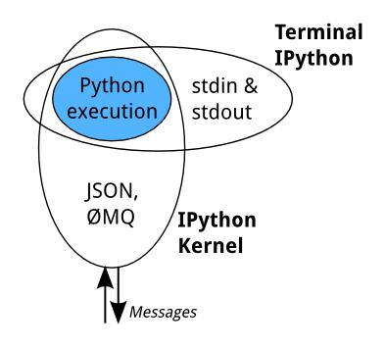

Figure 2.1 Kernel Execution

All the interfaces, like the Notebook, the Qt console, IPython console in the terminal, and third party interfaces use the IPython Kernel. The IPython Kernel is a separate process which is responsible for running user code, and things like computing possible completions. Frontends, like the notebook or the Qt console, communicate with the IPython Kernel using JSON messages sent over ZeroMQ sockets. The core execution machinery for the kernel is shared with terminal IPython as shown in the figure 2.1. A kernel process can be connected to more than one frontend simultaneously. In this case, the different frontends will have access to the same variables.

The Notebook :

The Notebook interface as seen in figure 2.2 does something extra. In addition to running the code, it stores code and output, together with markdown notes, in an editable document called a notebook. When it is saved, this is sent from the browser to the notebook server, which saves it on disk as a JSON file with a .ipynb extension.
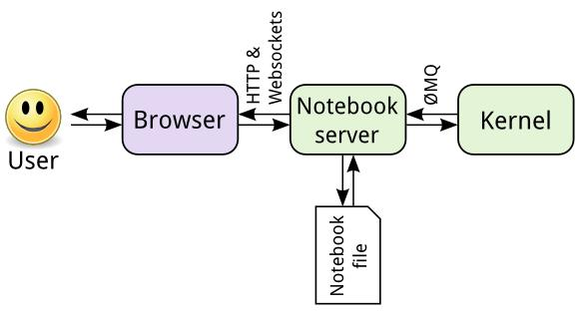

Figure 2.2 User to Notebook Interface

Department of CSE, RNSIT | 2018-2019 | 6

Chapter 2 REQUIREMENT ANALYSIS, TOOLS AND TECHNOLOGIES

The notebook server, not the kernel, is responsible for saving and loading notebooks, so the user can edit notebooks even if the kernel is unavailable for that language, the user just won’t be able to run code. The kernel doesn’t know anything about the notebook document: it just gets sent cells of code to execute when the user runs them.

The Notebook design :

A design notebook is a way for a designer or engineer to keep a history of his or her desugn project from start to finish. It is a place to record research, observation, ideas, drawings, comments, and questions during the design process.

Notebook dashboard :

When a new notebook document is created, the user will be presented with the notebook name, a menu bar, a toolbar and an empty code cell.
- Notebook name: The name displayed at the top of the page, next to the Jupyter logo, reflects the name of the .ipynb file. Clicking on the notebook name brings up a dialog which allows the user to rename it. Thus, renaming a notebook from “Untitled0” to “My first notebook” in the browser, renames the Untitled0.ipynb file to My first notebook.ipynb.

- Menu bar: The menu bar presents different options that may be used to manipulate the way the notebook functions.

- Toolbar: The tool bar gives a quick way of performing the most-used operations within the notebook, by clicking on an icon.

- Code cell: the default type of cell; read on for an explanation of cells.

Structure of a Notebook document :

The notebook consists of a sequence of cells. A cell is a multiline text input field, and its contents can be executed by using Shift-Enter, or by clicking either the “Play” button the toolbar, or “Cell Run” in the menu bar. The execution behavior of a cell is determined by the cell’s type. There are three types of cells: code cells, markdown cells, and raw cells. Every cell starts off being a code cell, but its type can be changed by using a drop-down on the toolbar.
- Code cells

A code cell allows to edit and write new code, with full syntax highlighting and tab completion. The programming language the user uses depends on the kernel, and the
//

Department of CSE, RNSIT | 2018-2019 | 7

Chapter 2 REQUIREMENT ANALYSIS, TOOLS AND TECHNOLOGIES
//

default kernel (IPython) runs Python code. When a code cell is executed, code that it
contains is sent to the kernel associated with the notebook. The results that are returned from this computation are then displayed in the notebook as the cell’s output.

- Markdown Cells

The computational process can be documented in a literate way, alternating descriptive text with code, using rich text. In IPython this is accomplished by marking up text with the Markdown language. The corresponding cells are called Markdown cells. The Markdown language provides a simple way to perform this text markup, that is, to specify which parts of the text should be emphasized (italics), bold, form lists, etc. When a Markdown cell is executed, the Markdown code is converted into the corresponding formatted rich text. Markdown allows arbitrary HTML code for formatting.

- Raw Cells

Raw cells provide a place in which output can be written directly. Raw cells are not evaluated by the notebook. Raw cells arrive in the destination format unmodified. For example, the can type full LaTeX into a raw cell, which will only be rendered by LaTeX.

The Output format :

A code cell can have a variety of outputs (stream data or rich mime-type output). These correspond to messages produced as a result of executing the cell. All outputs have an output_type field, which is a string defining what type of output it is.

Stream output and Display data :

{

"output_type" : "stream",

"name" : "stdout", # or stderr

"text" : ["multiline stream text"],

}

Rich display outputs, as created by display_data messages, contain data keyed by mime-type. This is often called a mime-bundle, and shows up in various locations in the notebook format and message spec. The metadata of these messages may be keyed by mime-type as well. This program explanation can be seen below.

//

Department of CSE, RNSIT | 2018-2019 | 8

Chapter 2 REQUIREMENT ANALYSIS, TOOLS AND TECHNOLOGIES

//
{

"output_type" : "display_data",

"data" : {

"text/plain" : ["multiline text data"],

"image/png": ["base64-encoded-png-data"],

"application/json": {

- JSON data is included as-is "json": "data",

},

},

"metadata" : {

"image/png": {

"width": 640,

"height": 480,

},

},

}

Execute result :

Results of executing a cell are stored in execute_result outputs. execute_result outputs are identical to display_data, adding only a execution_count field, which must be an integer. This program explanation can be seen below.
{

"output_type" : "execute_result",

"execution_count": 42,

"data" : {
"text/plain" : ["multiline text data"],

"image/png": ["base64-encoded-png-data"],

"application/json": {

- JSON data is included as-is "json": "data",

},

},

"metadata" : {

"image/png": {

"width": 640,

"height": 480,

//

},

},

}
//

Department of CSE, RNSIT | 2018-2019 | 9

Chapter 2 REQUIREMENT ANALYSIS, TOOLS AND TECHNOLOGIES

Error :

Failed execution may show a traceback.

{

'ename' : str, # Exception name, as a string

'evalue' : str, # Exception value, as a string

- The traceback will contain a list of frames,

- represented each as a string.

'traceback' : list,

}

Raw NBConvert cells :

A raw cell is defined as content that should be included unmodified in nbconvert output. For example, this cell could include raw LaTeX for nbconvert to pdf via latex, or restructured text for use in Sphinx documentation. The notebook authoring environment does not render raw cells.

The only logic in a raw cell is the format metadata field. If defined, it specifies which nbconvert output format is the intended target for the raw cell. When outputting to any other format, the raw cell’s contents will be excluded.

//

/
Department of CSE, RNSIT | 2018-2019 | 10

Chapter 3

DESIGN AND IMPLEMENTATION

3.1 Block diagram

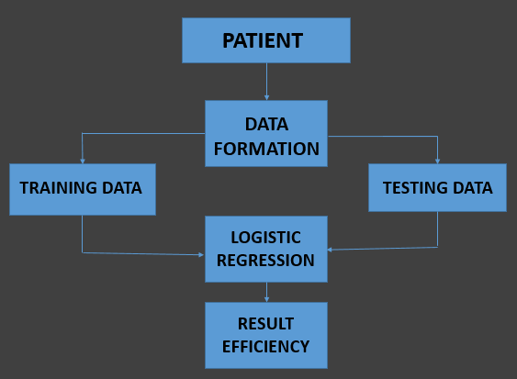
Figure 3.1 A block diagram representing the design of formulation of solution

The block diagram represented in figure 3.1 shows the formulation of solution for the given problem statement. The data formation first happens by combining the data of all patients. This data is then split into training set and test set. The logistic regression algorithm is initially applied on the training data and later checked against test data.

3.2 Functional modules
Computing correlation between dependent and independent variables :
Correlation is any of a broad class of statistical relationships involving dependence. In common usage it most often refers to how close two variables are to having a linear relationship with each other. Familiar examples of dependent phenomena include the correlation between the physical statures of parents and their offspring, and the correlation between the demand for a limited supply product and its price.

Department of CSE, RNSIT 2018-2019 11

Chapter 3 DESIGN AND IMPLEMENTATION

The following code snippet shows the functional module for computing correlation.
import numpy as np
def correlation(x, y):
mean_x = x.mean()
mean_y = y.mean()
subtracted_mean_x = x – mean_x
subtracted_mean_y = y – mean_y
x_times_y = subtracted_mean_x * subtracted_mean_y
x_squared = subtracted_mean_x ** 2
y_squared = subtracted_mean_y ** 2
return x_times_y.sum() / np.sqrt(x_squared_sum() * y_squared_sum())

Implementing Logistic Regression algorithm on the dataset :
Logistic Regression is a Machine Learning classification algorithm that is used to predict the probability of a categorical dependent variable. In logistic regression, the dependent variable is a binary variable that contains data coded as 1 (yes, success, etc.) or 0 (no, failure, etc.). In other words, the logistic regression model predicts P(Y=1) as a function of X.
Given a set of inputs X, we want to assign them to one of two possible categories (0 or 1). Logistic regression models the probability that each input belongs to a particular category. A function takes inputs and returns outputs. To generate probabilities, logistic regression uses a function that gives outputs between 0 and 1 for all values of X. There are many functions that meet this description, but the used in this case is the logistic function also called sigmoid.
The following code snippet shows the functional module for logistic regression.

class LogisticRegression:
def __init__(self, lr=0.01, num_iter=100000, fit_intercept=True, verbose=False):
self.lr = lr
self.num_iter = num_iter
self.fit_intercept = fit_intercept
def __add_intercept(self, X):
intercept = np.ones((X.shape[0], 1))
return np.concatenate((intercept, X), axis=1)

Department of CSE, RNSIT | 2018-2019 | 12
Chapter 3 DESIGN AND IMPLEMENTATION

def __sigmoid(self, z):
return 1 / (1 + np.exp(-z))
def __loss(self, h, y):
return (-y * np.log(h) - (1 - y) * np.log(1 - h)).mean()
def fit(self, X, y):
if self.fit_intercept:
X = self.__add_intercept(X)
# weights initialization
self.theta = np.zeros(X.shape[1])
for i in range(self.num_iter):
z = np.dot(X, self.theta)
h = self.__sigmoid(z)
gradient = np.dot(X.T, (h - y)) / y.size
self.theta -= self.lr * gradient
if(self.verbose == True and i % 10000 == 0):
z = np.dot(X, self.theta)
h = self.__sigmoid(z)
print(f'loss: {self.__loss(h, y)} \t')
def predict_prob(self, X):
if self.fit_intercept:
X = self.__add_intercept(X)
return self.__sigmoid(np.dot(X, self.theta))
def predict(self, X, threshold):
return self.predict_prob(X) >= threshold

Computing efficiency and accuracy of the implemented algorithm :
In order to find how efficiently our logistic regression model fits our data, it is required to know the efficiency and accuracy of the implemented algorithm. The following code snippet shows how efficiency and accuracy are calculated for the logistic regression algorithm applied.
model = LogisticRegression(C=1e20)
%time model.fit(X, y)
CPU times: user 0 ns, sys: 0 ns, total: 0 ns
Wall time: 854 µs
preds = model.predict(X)
# accuracy
(preds == y).mean()
1.0
model.intercept_, model.coef_

Department of CSE, RNSIT | 2018-2019 | 13
Chapter 3 DESIGN AND IMPLEMENTATION

3.3 Algorithm/ Pseudocode

Supervised Learning :

Supervised learning is the Data mining task of inferring a function from labelled training data. The training data consist of a set of training examples. In supervised learning, each example is a pair consisting of an input object (typically a vector) and a desired output value (also called the supervisory signal).
A supervised learning algorithm analyses the training data and produces an inferred function, which can be used for mapping new examples.
- Labelled data: Data consisting of a set of training examples, where each example is a
pair consisting of an input and a desired output value (also called the supervisory signal, labels, etc.)
- Classification: The goal is to predict discrete values, e.g. {1, 0}, {True, False}, {spam, not spam}.
- Regression: The goal is to predict continuous values, e.g. home prices.

A regression problem is when the output variable is a real or continuous value, such as “salary” or “weight”. Many different models can be used; the simplest is the linear regression. It tries to fit data with the best hyper-plane which goes through the points. The dependency between two data sets can be seen in figure 3.2
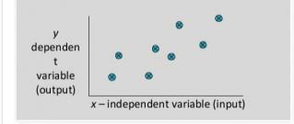

Figure 3.2 Dependency between Two Dataset

The supervised learning workflow as shown in figure 3.3 tells us how the training and testing of the machine take place. There are certain rules/steps which has to be followed in the order to train our machine. These steps are as follows:
- One has to take a data set in order to train and test the machine, the data set should relevant to our problem, for which they are training the machine.
- Then they have to find a relation between all the attribute of the data set and have to

Department of CSE, RNSIT | 2018-2019 | 14

Chapter 3 DESIGN AND IMPLEMENTATION

- find the dependency of the data set with each other, this help to select most appropriate attributes to train the machine.
- Then they have to break our data set in two sets: a) Training data set (consist of 70 to 85 % of data set), b) Test data set (consist of about 15 to 30 % of the data set).

- They select most appropriate algorithm to train the machine, in initial stage of machine there are some errors which can be resolved with the error function they have used in our algorithm in each repeated iterations of training.

- After the machine is trained with the algorithm used and training data with the minimum error they have to calculate the accuracy of the machine by using the testing data.

- The expected result is labelled and matches with original result to check the accuracy.
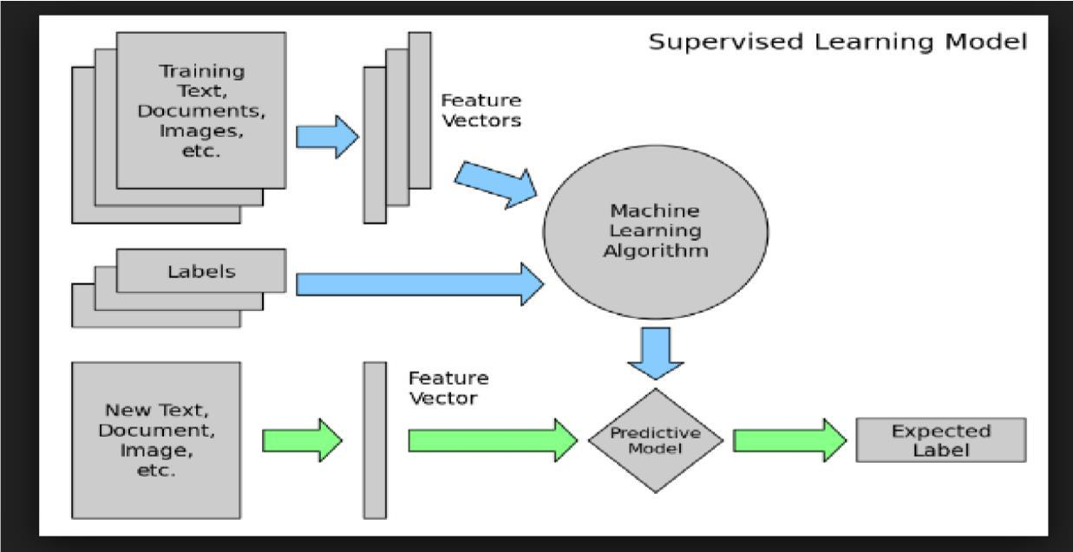

Figure 3.3 Supervised Learning Workflow

Logistic Regression :

Logistic regression is used to find the probability of event_ success and event failure. The dependent variable must be binary in nature (0 or 1). It is widely used for classification problems. Logistic regression as a special case of linear regression when the outcome variable is categorical, where the user is using log of odds as dependent variable. In simple words, it predicts the probability of occurrence of an event by fitting data to a log it function.
- Binomial: target variable can have only 2 possible types: “0” or “1” which may represent “win” vs. “loss”, “pass” vs. “fail”, “dead” vs. “alive”, etc.

Department of CSE, RNSIT | 2018-2019 | 15

Chapter 3 DESIGN AND IMPLEMENTATION

- Multinomial: target variable can have 3 or more possible types which are not ordered (i.e. types have no quantitative significance) like “disease A” vs. “disease B” vs. “disease C”.

- Ordinal: it deals with target variables with ordered categories. For example, a test

score can be categorized as: “very poor”, “poor”, “good”, “and very good”. Here, each category can be given a score like 0, 1, 2, and 3.

Pseudocode :

Reading the CSV Data File and Cleaning the Data :

data = pd.read_csv('breast-cancer.xls')
data.head()
df = data.drop(data.columns[32], axis=1)
df = df.drop('id', axis=1)
df['diagnosis'] = (df['diagnosis'] != 'B').astype(int)
df.head()
df.shape
df.columns
df.isnull().sum()

As shown in the code snippet above, the first step to train the machine is to read and clean the dataset which is being used to train and test the machine. read_csv() function is used which is defined under the pandas module. The read_csv() function takes one argument which is the name of dataset file name.

In the next line pandas.DataFrame.astype() function is used which casts a pandas object to specific datatype. In this case, the attribute ‘DIAGNOSIS’ is typecasted whose value is not ‘B’ as an integer value.

In the next step the column is dropped which contains ‘unnamed’ values, using pandas.Series.str.Contains (pat,case=False). After this a check is done for the attributes which contain the NULL values. df.isnull ().sum() is used which gives how many null values are present in total in the data set.

Finding the correlation between the data :

corr = df.corr()
corr.nlargest(31,['diagnosis'])['diagnosis']

Department of CSE, RNSIT | 2018-2019 | 16
Chapter 3 DESIGN AND IMPLEMENTATION

df.columns
X =df[[ 'concave points_worst', 'perimeter_worst',
'concave points_mean', 'radius_worst',
'perimeter_mean', 'area_worst',
'radius_mean', 'area_mean',
'concavity_mean', 'concavity_worst',
'compactness_mean', 'compactness_worst',
'radius_se', 'perimeter_se', 'area_se']]
Y = df['diagnosis']

After cleaning the data, to find the correlation between the attribute for this, dataframe.corr() module is used, which is defined in pandas. The correlation helps in judging which attribute data is most dependent as shown in the code snippet above.
Now find the correlation between the data. All the attributes should be removed from the data set which affect the class label the least, as the result of detection does not depend on these data attribute. For this case the following attributes are dropped :

["id","texture_mean","smoothness_mean","concavepoints_mean","texture_worst","smoothne ss_worst", "symmetry_worst","fractal_dimension_mean"] .The parameters for X are chosen, which do not contain the diagnosis value.

Training the Model and Testing the Model :

# Splitting the dataset into training and test set
X_train, X_test, Y_train, Y_test = train_test_split(X, Y, test_size=0.2, random_state=1)
model = LogisticRegression()
model.fit(X_train,Y_train)
model = LogisticRegression()
model.fit(X_test,Y_test)

Last but not least, the dataset has to be split into the training and testing dataset. It is distributed in the ratio of (80:20) % for training and testing part, then our machine is trained using logistic regression which is supported in sklearn library.

In order to achieve this, the data that is split is set as x_train and x_test and Y_train and Y_test using train_test_split module. After this our model as Logistic Regression is set which is defined in the linear_model. Then model.fit(x_train,Y_train ) is used to train the model. After training gets over, the data is tested against the testing data and the accuracy is predicted for the model using model.pred(), and then the score of model is checked.

Department of CSE, RNSIT | 2018-2019 | 17
Chapter 3 DESIGN AND IMPLEMENTATION

3.4 Libraries used

SciKit-learn :

Scikit-learn is a free software machine learning library for the Python programming language. It features various classification, regression and clustering algorithms including support vector machines, random forests, gradient boosting, k-means and DBSCAN, and is designed to interoperate with the Python numerical and scientific libraries NumPy and SciPy.

The scikit-learn project started as scikits-.learn, a Google Summer of Code project by David Cournapeau. Its name stems from the notion that it is a "SciKit" (SciPy Toolkit), a
separately-developed and distributed third-party extension to SciPy. The original codebase
was later rewritten by other developers. In 2010 Fabian Pedregosa, Gael Varoquaux, Alexandre Gramfort and Vincent Michel, all from INRIA took leadership of the project and made the first public release on February the 1st 2010. Of the various scikits, scikit-learn as well as scikit-image were described as "well-maintained and popular" in November 2012.

Numpy and Pandas :

NumPy is a library for the Python programming language, adding support for large, multi-dimensional arrays and matrices, along with a large collection of high-level mathematical functions to operate on these arrays. NumPy enriches the programming language Python with powerful data structures, implementing multi-dimensional arrays and matrices. These data structures guarantee efficient calculations with matrices and arrays. The implementation is even aiming at huge matrices and arrays, better known under the heading of "big data".
The ancestor of NumPy, Numeric, was originally created by Jim Hugunin with contributions from several other developers. In 2005, Travis Oliphant created NumPy by incorporating features of the competing Numarray into Numeric, with extensive modifications. NumPy is open-source software and has many contributors. By using them in Python programming, they can be used with two simple commands:

>>> import numpy

The core functionality of NumPy is its "ndarray", for n-dimensional array, data structure. These arrays are strided views on memory. In contrast to Python's built-in list data structure (which, despite the name, is a dynamic array) these arrays are homogeneously typed: all elements of a single array must be of the same type.
Department of CSE, RNSIT | 2018-2019 | 18
Chapter 3 DESIGN AND IMPLEMENTATION

Pandas is a software library written for the Python programming language for data manipulation and analysis. In particular, it offers data structures and operations for manipulating numerical tables and time series. It is free software released under the three-clause BSD license. The name is derived from the term "panel data", an econometrics term for data sets that include observations over multiple time periods for the same individuals. Library features are:
- DataFrame object for data manipulation with integrated indexing.

- Tools for reading writing data between in-memory data structures different file formats.

- Data alignment and integrated handling of missing data.

- Reshaping and pivoting of data sets.

- Label-based slicing, fancy indexing, and sub setting of large data sets.

- Data structure column insertion and deletion.

- Group by engine allowing split-apply-combine operations on data sets.

- Data set merging and joining.

- Hierarchical axis indexing to work with high-dimensional data in a lower-dimensional data structure.

- Time series-functionality: Date range generation and frequency conversion, moving window statistics, moving window linear regressions, date shifting and lagging.

Matplotlib :

Matplotlib is a plotting library for the Python programming language and its numerical mathematics extension NumPy. It provides an object-oriented API for embedding plots into applications using general-purpose GUI toolkits like Tkinter, wxPython, Qt, or GTK+.There is also a procedural "pylab" interface based on a state machine (like OpenGL), designed to closely resemble that of MATLAB, though its use is discouraged. SciPy makes use of matplotlib.
Matplotlib was originally written by John D. Hunter, has an active development community, and is distributed under a BSD-style license. Michael Droettboom was nominated as matplotlib's lead developer shortly before John Hunter's death in August 2012, and further joined by Thomas Caswell.

As of 23 June 2017, matplotlib 2.0.x supports Python versions 2.7 through 3.6. Matplotlib 1.2 is the first version of matplotlib to support Python 3.x. Matplotlib 1.4 is the last version of matplotlib to support Python 2.6.
Department of CSE, RNSIT | 2018-2019 | 19
Chapter 3 DESIGN AND IMPLEMENTATION

3.5 Configuration

Anaconda :

Anaconda is a free and open source distribution of the Python and R programming languages for data science and learning related applications (large-scale data processing, predictive analytics, scientific computing), that aims to simplify management and deployment. Anaconda3 includes Python 3.6. Anaconda Navigator is a desktop graphical user interface (GUI) included in Anaconda distribution that allows users to launch applications and manage anaconda packages, environments and channels without using command-line commands. Navigator can search for packages on Anaconda Cloud or in a local Anaconda Repository, install them in an environment, run the packages and update them. It is available for Windows, macOS and Linux.

The following are the system requirements:
- License: Free use and redistribution under the terms of the Anaconda End User License Agreement.
- Operating system: Windows Vista or newer, 64-bit macOS 10.10+, or Linux, including Ubuntu, RedHat, CentOS 6+, and others. Windows XP supported on Anaconda versions 2.2 and earlier. See lists. Download it from our archive.
- System architecture: 64-bit x86, 32-bit x86 with Windows or Linux, Power8 or Power9. Minimum 3 GB disk space to download and install.

Installation of Anaconda on Windows :

The most common way of downloading anaconda is to go to www.python.org and choose the appropriate version and click on download. The following steps must be followed to install anaconda, after downloading it.

- Download the Anaconda installer.

- Optional: Verify data integrity with MD5 or SHA-256. More info on hashes

- Double click the installer to launch. Click

- Click Next.

- Read the licensing terms and click “I Agree”.

- Select an install for “Just Me” unless you’re installing for all users (which requires Windows Administrator privileges) and click next.

Department of CSE, RNSIT | 2018-2019 | 20
Chapter 3 DESIGN AND IMPLEMENTATION

- Select a destination folder to install Anaconda and click the Next button. See FAQ.

- Choose whether to add Anaconda to your PATH environment variable. It is recommended to not add Anaconda to the PATH environment variable, since this can interfere with other software. Instead, use Anaconda software by opening Anaconda Navigator or the Anaconda Prompt from the Start Menu.

- Choose whether to register Anaconda as the default Python 3.6. Unless you plan on installing and running multiple versions of Anaconda, or multiple versions of Python, accept the default and leave this box checked.

- Click the Install button. If the user wants to watch the packages Anaconda is installing, click Show Details.

- Click the Next button.

- Optional: To install VS Code, click the Install Microsoft VS Code button. After the install completes click the Next button.

- Or to install Anaconda without VS Code, click the Skip button.

- After the installation is complete, verify it by opening Anaconda Navigator, a program that is included with Anaconda: from the Windows Start menu, select the shortcut Anaconda Navigator. If Navigator opens, the user has successfully installed Anaconda. If not, check that all the above steps are complete, then see Help page.

Department of CSE, RNSIT | 2018-2019 | 21
Chapter 4

OBSERVATIONS AND RESULTS

4.1 Testing

Software Testing is the process used to help identify the correctness, completeness, security and quality of the developed computer software. Testing is the process of technical investigation and includes the process of executing a program or application with the intent of finding errors.

Unit Testing :

Unit testing is a level of software testing where individual units/ components of a software are tested. The purpose is to validate that each unit of the software performs as designed. A unit is the smallest testable part of any software. It usually has one or a few inputs and usually a single output. Unit testing has been done to check whether the cancer dataset is loaded correctly.
The table 4.1 checks whether the dataset is loaded accordingly as the output shown in figure 4.1.

Table 4.1 Unit test case for Dataset Loading

Sl No. of test case: | 1
Name of test: | Check test
Item / Feature being tested: | Input Dataset
Sample Input: | Syntax to display top 5 element from dataset specified in
 | a particular directory
Expected output: | Displays top 5 elements
Expected output: | Displays top 5 elements
Remarks | Test Succeeded
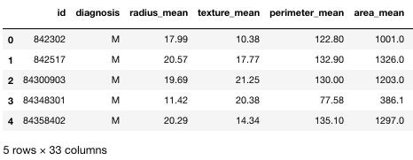

Figure 4.1 Dataset Loaded

Department of CSE, RNSIT 2018-2019 22
Chapter 4 OBSERVATIONS AND RESULTS

In table 4.2, Checking is done for null/NA value after dropping.

Table 4.2 Unit test to check for null/NA value

Sl No. of test case: | 2
Name of test: | Check test
Item / Feature being tested: | Dataframe object
Sample Input: | Drop command to drop null/NA values
Expected output: | No null/NA value in dataframe
Expected output: | No null/NA value in dataframe
Remarks | Test Succeeded

Integration Testing :

Integration testing is done to test the modules/components when integrated to verify that they work as expected i.e. to test the modules which are working fine individually does not have issues when integrated. It is used to check the train and test split function as shown in table 4.3 and the output seen in figure 4.2 as shown below.

Table 4.3 Integration test to check for train-test-split

Sl No. of test case: | 1
Name of test: | Check test
Item / Feature being tested: | Train-test-split function
Sample Input: | Input features and ratio and check for the correct splitting
 | of the dataframe
Expected output: | Split according to the given ratio
Expected output: | Splitted according to the given ratio
Remarks | Test Succeeded
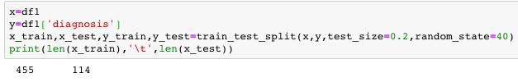

Figure 4.2 Splitting the dataset into the ratio 4:1

Department of CSE, RNSIT | 2018-2019 | 23

Chapter 4 OBSERVATIONS AND RESULTS

System Testing :

System Testing (ST) is a black box testing technique performed to evaluate the complete system the system's compliance against specified requirements. The software or hardware is testing conducted on a complete, integrated system to evaluate the system’s compliance with its specified requirements. System testing takes, as its input, all of the ‘integrated’ software components that have successfully passed integration testing and also the software system itself integrated with any applicable hardware system(s).

In table 4.4, one is checking accuracy using logistic regression algorithm and the output is shown in figure 4.3 as shown below.

Table 4.4 System test to check the accuracy using Logistic Regression

Sl No. of test case: | 1
Name of test: | Check test
Item / Feature being tested: | Learning algorithm’s efficiency
Sample Input: | Training features and output feature
Expected output: | Some accuracy of the training model
Expected output: | Training accuracy: 96.04%
 | Testing accuracy: 92.10%
Remarks | Test Succeeded
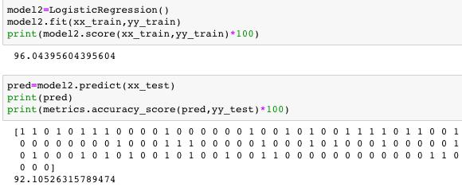

Figure 4.3 Accuracy using Logistic Regression

Department of CSE, RNSIT | 2018-2019 | 24

Chapter 4 OBSERVATIONS AND RESULTS

In table 4.5, one is checking accuracy using Random Forest Algorithm and the output is shown in figure 4.4 as shown below.

Table 4.5 System test to check the accuracy using Random Forest

Sl No. of test case: | 2
Name of test: | Check test
Item / Feature being tested: | Learning algorithm’s efficiency
Sample Input: | Training feature and output feature
Expected output: | Some efficiency of the learning algorithm
Expected output: | Improved efficiency
 | Training efficiency: 99.78%
 | Testing efficiency: 94.73%
Remarks | Test Succeeded
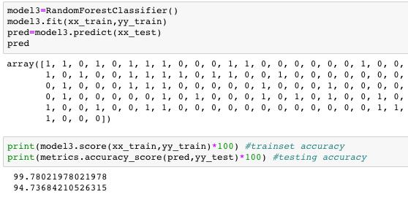

Figure 4.4 Accuracy using Random Forest Algorithm

4.2 Graphs

Seaborn countplot shows the count in either of the diagnosis class, where ‘M’ represents 1 and ‘B’ represents 0 as shown in figure 4.5 below.

Department of CSE, RNSIT | 2018-2019 | 25

Chapter 4 OBSERVATIONS AND RESULTS

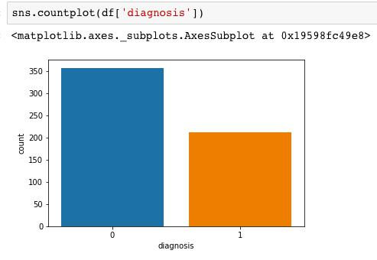

Figure 4.5 Diagnosis Count

Matplotlib.pyplot.scatter showing the variation of ‘perimeter_mean’ with respect to ‘area_mean’ attributes of the size of the tumor. pandas.Dataframe.corr compute pairwise correlations of columns, excluding null/NA values as shown in figure 4.6 below.

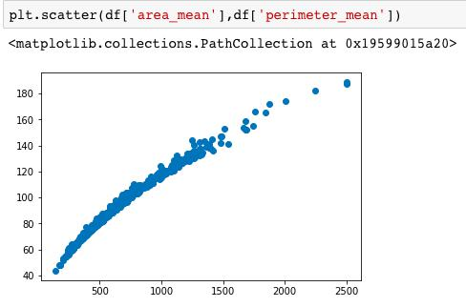

Figure 4.6 Relation between average area and perimeter of the Tumor

The below figure 4.7 it is showing the dependencies of the different column attributes (chosen as the feature column) on each other.

Department of CSE, RNSIT 2018-2019 26
Chapter 4 OBSERVATIONS AND RESULTS

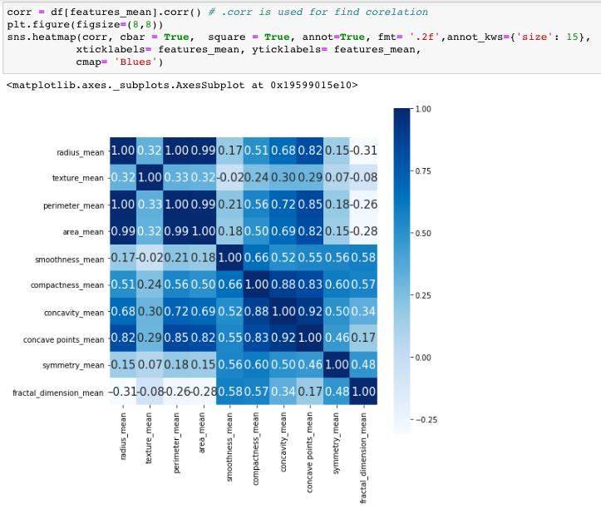

Figure 4.7 Correlation Square showing relation between each columns

4.3 Results/ Snapshots

The figure 4.8 below shows the python code for importing the required libraries and reading the dataset.

Department of CSE, RNSIT | 2018-2019 | 27

Chapter 4 OBSERVATIONS AND RESULTS

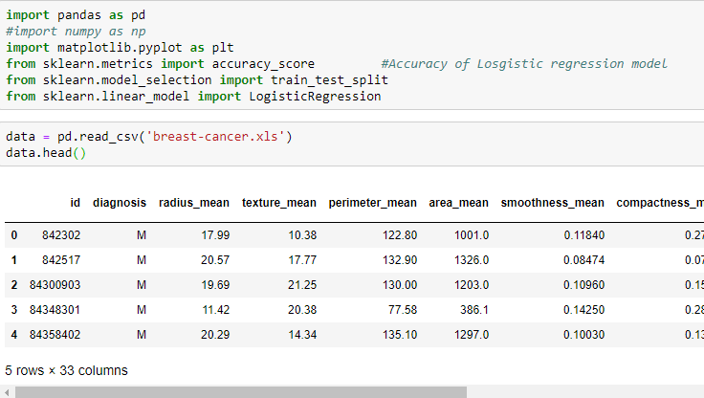
Figure 4.8 Importing required libraries and reading the dataset.

While training the data, X is chosen based on the correlation with respect to diagnosis column (>0.5) and the Y is the Diagnosis column itself as shown in figure 4.9 below.
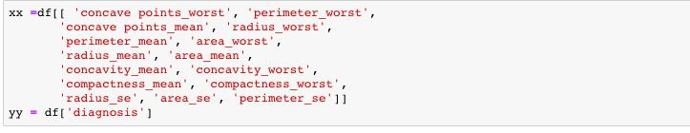

Figure 4.9 Choosing X and Y for Training the model

Scikit-Learn has a function train-test-split() which can be used to randomly split the data into training and testing set as shown in figure 4.10 below.

Figure 4.10 Splitting data into training and testing set in ratio 4:1

Department of CSE, RNSIT | 2018-2019 | 28

Chapter 4 OBSERVATIONS AND RESULTS
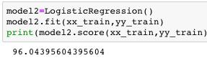

Figure 4.11 Training Accuracy using Logistic Regression
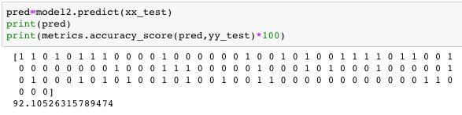

Figure 4.12 Testing Accuracy using Logistic Regression

The training and testing accuracy for logistic regression can be seen in figure 4.11 and 4.12.
In order to improve the accuracy of the model considering the same feature columns another learning method i.e. Random Forest Classifier as seen in figure 4.13 and 4.14.
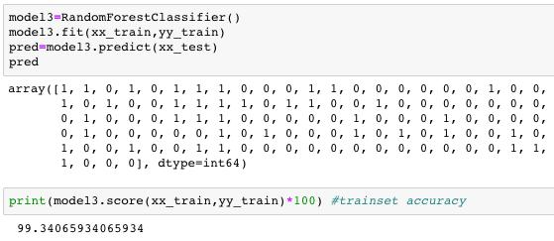

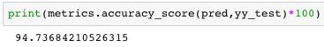
Figure 4.13 Training Accuracy using Random Forest

Figure 4.14 Testing Accuracy using Random Forest

Hence the training as well as the testing accuracy obtained in the Random Forest algorithm is relatively higher than the Logistic regression algorithm considering the same feature columns for training in either case.

Department of CSE, RNSIT | 2018-2019 | 29

Chapter 5

CONCLUSION AND FUTURE WORK

5.1 Conclusion

The project “Finding the Stage of Cancer malignant or benign” is successful in predicting the stage of breast cancer with a good accuracy rate depending on the various attributes given by the user in the collected data set, thereby eliminating the human error as the decision process is successfully automated.

It shows Logistic Regression modelling is fairly simple. It successfully classifies the cancer stage based on the important features provided. For datasets with a small amount of variables it is a viable method. This project is a good introduction to training and test sets which are very important components not just to data science but to statistical learning overall.

5.2 Limitations and future work

Limitations :
Though the project focuses on using logistic regression, various other machine learning models like Naïve Bayes, Random Forest, KNN etc., can be used which have improved accuracy than Logistic Regression.
Future work :

The following enhancements can be made in the project which would make it more suitable and an intelligent model to classify various real world problems.

- Better regression techniques can be applied to obtain the best possible accuracy.

- Can be converted into a real time analysis system for insights on-the-fly.

- Can include more illustrative graphs and plots for a deeper understanding of the dataset.

Department of CSE, RNSIT 2018-2019 30
REFERENCES

[1] Tom M.Michell, Machine learning, Indian Edition 2013, McGraw Hill Education.

[2] Pang-Ning Tan, Michael Steinbach, Vipin Kumar: Introduction to Data mining, Pearson, first impression,2014.

[3] Jiawei Han, Micheline Kamber, Jian Pei: Data mining – concepts and techniques, 3rd edition, Morgan Kaufmann publisher, 2012.

[4] http://www.python.org/

[5] http://www.quora.com/

[6] http://towardsdatascience.com/

[7] http://www.kaggle.com/

Department of CSE, RNSIT 2018-2019 31

